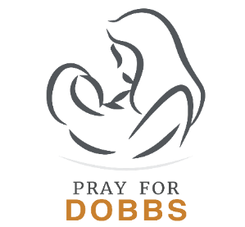

Sample Announcements

Promoting the National Prayer Event

Bulletin/Newsletter/Website Announcement

Dobbs v. Jackson Women’s Health Organization could impact the fate of millions of preborn children and their mothers. Register at prayfordobbs.com to virtually join thousands of Catholic, Orthodox, and Protestant Christians across the country on November 18 at 8 PM (EST) as we come together in prayer.

Pulpit Announcement

Join Catholic, Orthodox, and Protestant Christians nationwide in praying for the outcome to the Dobbs v. Jackson Women’s Health Organization case and for the lives of millions of preborn children and their mothers. See the bulletin for more information.

Invitation to Participate in Pray for Dobbs

The Supreme Court case Dobbs v. Jackson Women’s Health Organization could impact the fate of millions of preborn children and their mothers. Join thousands of Catholic, Orthodox, and Protestant Christians uniting in prayer and fasting! Learn more and sign up for updates at prayfordobbs.com.

Reminder to Pray for Dobbs

The Supreme Court case Dobbs v. Jackson Women’s Health Organization could impact the fate of millions of preborn children and their mothers. Trusting that the Lord hears us, let us remember to pray this week for a decision to that case that safeguards their lives. For more information, visit prayfordobbs.com.

